ST. LAWRENCE COUNTY WORKFORCE DEVELOPMENT BOARD

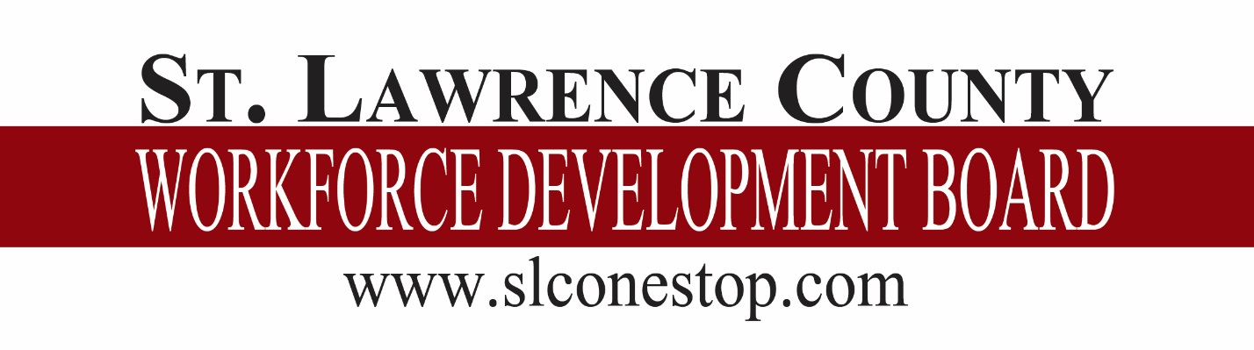

NON-CRIMINAL COMPLAINTS AND GRIEVANCES PROCEDURE

St. Lawrence County One-Stop System
Non-Criminal Complaints and Grievances Procedure
Approved by the St. Lawrence County Workforce Investment Board: May 19, 2004
Reaffirmed by the SLC Workforce Development Board: September 9, 2015
Updated by the SLC Workforce Development Board: June 13, 2018

INTRODUCTION

The Workforce Innovation and Opportunity Act (WIOA) Section 181(c) and the Rules and Regulations 20 CFR 683.60 require the establishment of a complaint/grievance procedure by each Local Area, State and direct recipient of funds under Title I.

As a participant, service provider, or interested party, this document serves to inform you of the procedure whereby you may settle any difference or non-criminal complaint that may arise, free from coercion, restraint, interference, discrimination or reprisal.

PROCEDURE

The Workforce Development Board has implemented the complaint/grievance procedure outlined in Attachment A: WIOA Title I Compliant/Grievance Procedure. The procedure includes the handling of complaints/grievances arising in connection with WIOA Title I programs operated in their Local Workforce Development Area. Attachment A will be provided to customers as notification of the grievance procedure and will include a flowchart depicting the procedure.

The Workforce Development Board has appointed two officers to assume responsibility for investigating the complaint/grievance and seeking resolution.

Local Area Grievance Officer
Larry Fetcie, Senior Employment Counselor
80 State Highway 310, Suite 8
Canton, NY 13617
lfetcie@stlawco.org
315-229-3343

Local Level Hearing Officer
Penny Scott, Assistant Accounting Supervisor
80 State Highway 310, Suite 8
Canton, NY 13617
40b136@stlawco.org
315-229-3360

If these positions are vacated, a replacement must be appointed and Attachment B: Local Area Grievance Officers/Local Level Hearing Officers Form must be submitted to WIOA.Grievance.Procedure@labor.ny.gov.

NOTE TO SERVICE PROVIDERS

NYS Career Center partners, service providers and programs operated by subcontractors in the Local Workforce Development Area must utilize the complaint/grievance system established as outlined in Attachment A. You must inform all participants early of the grievance procedures they are to follow, should they need them.

CUSTOMER COMPLAINT INFORMATION FORM

If there is complaint, the complainant needs to fill out Attachment C: Customer Complaint Information Form. The form is to be completed and returned to the Career Center staff. If it is a discrimination complaint, the form is to be submitted to the Career Center Equal Opportunity Officer or sent to: NYS Department of Labor, Division of Equal Opportunity Development, State Office Campus, Building 12, Room 540, Albany, NY 12240.

Career Center Equal Opportunity Officer
Andrea Montgomery
Office for the Aging
80 State Highway 310
Canton, NY 13617
amontgomery@stlawco.org
315-229-3384

NON CRIMINAL/NON DISCRIMINATION COMPLAINT LOG

The Non-Criminal/Non Discrimination Complaint log (Attachment D) needs to be completed when complaints/grievances are received. It contains the elements that are needed for tracking purposes.

EXAMPLE OF NON CRIMINAL/NON DISCRIMINATION COMPLAINT LOG

St. Lawrence County One-Stop System
Non-Criminal Complaints and Grievances Procedure
Program Complaint Resolution Officer:

Complaint Log

Date Received | Complainant Name | Complaint Description | Date Referred Local Complaint Officer | Date Resolution reached/Hearing scheduled | Date of Hearing (if applicable)

LOCAL HEARING AND DECISION – REQUIRED ELEMENTS

Attachment E: Local Hearing and Decision – Required Elements lists the required components of a formal hearing and the decision based on the hearing.

- Hearing Notice Example

St. Lawrence County One-Stop System
Non-Criminal Complaints and Grievances Procedure

Hearing Notice

Date

Complainant Name
Complainant Address
City, State Zip Code

In compliance with Rules and Regulations (Section 667.600) of the Workforce Innovation and Opportunity Act (WIOA) “Subpart F – Grievance Procedures, Complaints, and State Appeals Processes” you are hereby notified that a hearing has been scheduled for the following:

DATE OF HEARING:

TIME OF HEARING:

LOCATION OF HEARING:

The purpose of this hearing is to provide you and/or your attorney, and/or your designated representative with the opportunity to address your grievance/complaint with the St. Lawrence County One-Stop System, as outlined in the “Non-Criminal Complaints and Grievances Procedure”. If you have any questions regarding the hearing, I have attached for your information the hearing guidelines that will be followed.

(Short and plain statement of the matters asserted)

Sincerely,

John Doe
Complaint Resolution Officer

XC: Party(ies) involved
WDB Chairperson
Hearing Committee members

- Hearing Guidelines

- The hearing shall be recorded.

- The complainant may be represented by an attorney or other designated representatives.

- To the extent possible, consistent with a fair determination of the issues, the identity of any person who has furnished information related to an investigation to a WIOA Title I related problem, shall be kept confidential.

- Within the limitations of the Freedom of Information Act, the complainant has a right of access to relevant records and documents that the program and/or Local Area maintains.

- The complainant and respondent have the right to an opportunity to present evidence relevant to the complaint, to call witnesses, and cross-examine other parties and their witnesses.

- Hearing Decision

A formal decision must contain the following:
- Name of Complainant
- Name of Respondent
- State the specific legal authority for holding the hearing
- Date of hearing
- List of Attendees
- Statement of issues
- Finding of facts
- Conclusions of law
- Opinion and reason for decision
- Signature of hearing officer
- Date signed

June 13, 2018
ST. LAWRENCE COUNTY WORKFORCE DEVELOPMENT BOARD
RESOLUTION NO. 18-F13-XX

AMENDING AND RESTATING POLICY NO. 5:

NON-CRIMINAL COMPLAINTS AND GRIEVANCES PROCEDURE POLICY

WHEREAS, the Workforce Innovation and Opportunity Act (WIOA) section 181(c) and the Rules and Regulations 20 CFR 683.60 require the establishment of a complaint/grievance procedure by each Local Area, State and direct recipient of funds under Title I, and

WHEREAS, Workforce Development System Technical Advisory No. 18-4 provides an outline of the procedure to ensure that a complaint is resolved promptly at the lowest level possible and that the complainant is advised of all steps taken to resolve the complaint, and

WHEREAS, under this procedure the local Workforce Development Board shall designate a staff member to act as the Local Area Complaint Resolution Officer and a staff member to act as the Hearing Officer to ensure the availability, coordination and timeliness of all elements of the complaint resolution procedure, and

NOW, THEREFORE, BE IT RESOLVED that the St. Lawrence County Workforce Development Board does hereby adopt the attached policy to address and resolve these issues, and

BE IT FURTHER RESOLVED that the St. Lawrence County Workforce Development Board does hereby appoint the Senior Employment Counselor as the Local Area Complaint Resolution Officer, and the Assistant Accounting Supervisor as the Hearing Officer, and

BE IT FURTHER RESOLVED that the St. Lawrence County Workforce Development Board Adopts the amended policy to reflect these changes.

